# Project Name

Mandalina

# Project Idea

Mandalina is a brand inspired by the warmth of homemade desserts crafted by a grandmother. The brand blends heritage, softness, and modern minimalism, with its identity inspired by the freshness of mandarin and the elegance of classic patisseries.

# Team Members (pentaRae)

- Alzahraa Farag (leader)  
- Hager Ali  
- Fayrouz Mahmoud  
- Sawsan Khaled

# Work Plan

## Research & Analysis

Researching brand story, heritage influence, and modern patisserie aesthetics.

## Audience personas

Target audience includes dessert lovers, modern café visitors, and individuals who appreciate warm storytelling in branding.

## Visual Identity

Soft, refined, and sincere — inspired by mandarin freshness and grandmother’s warmth.

## Logo design

Logo combines two ideas: the warmth of a grandmother’s presence and the freshness of mandarin.  
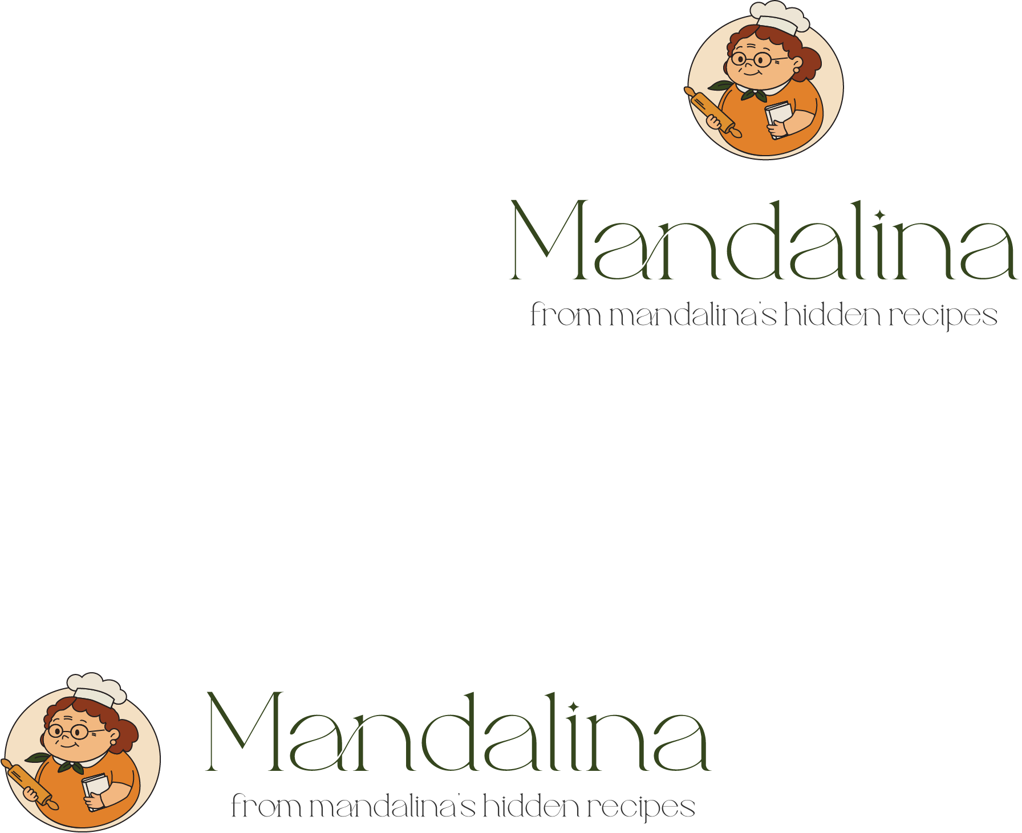

## Main Designs

**Social media posts (each member created 4 designs)  
– Main promotional poster for the brand  
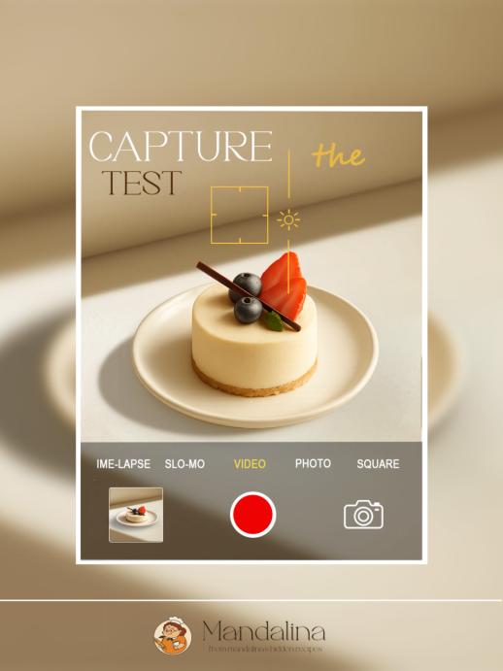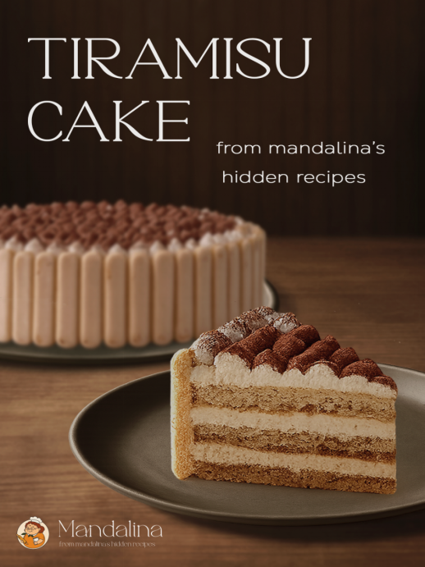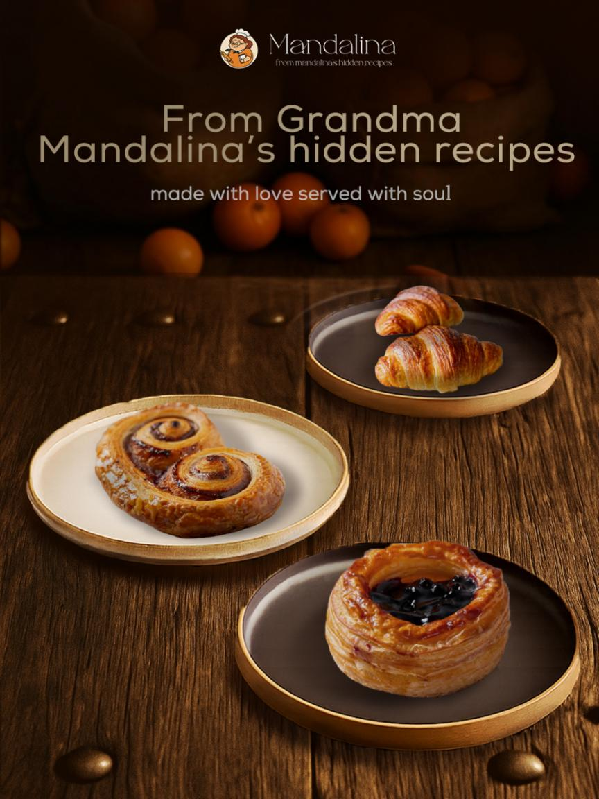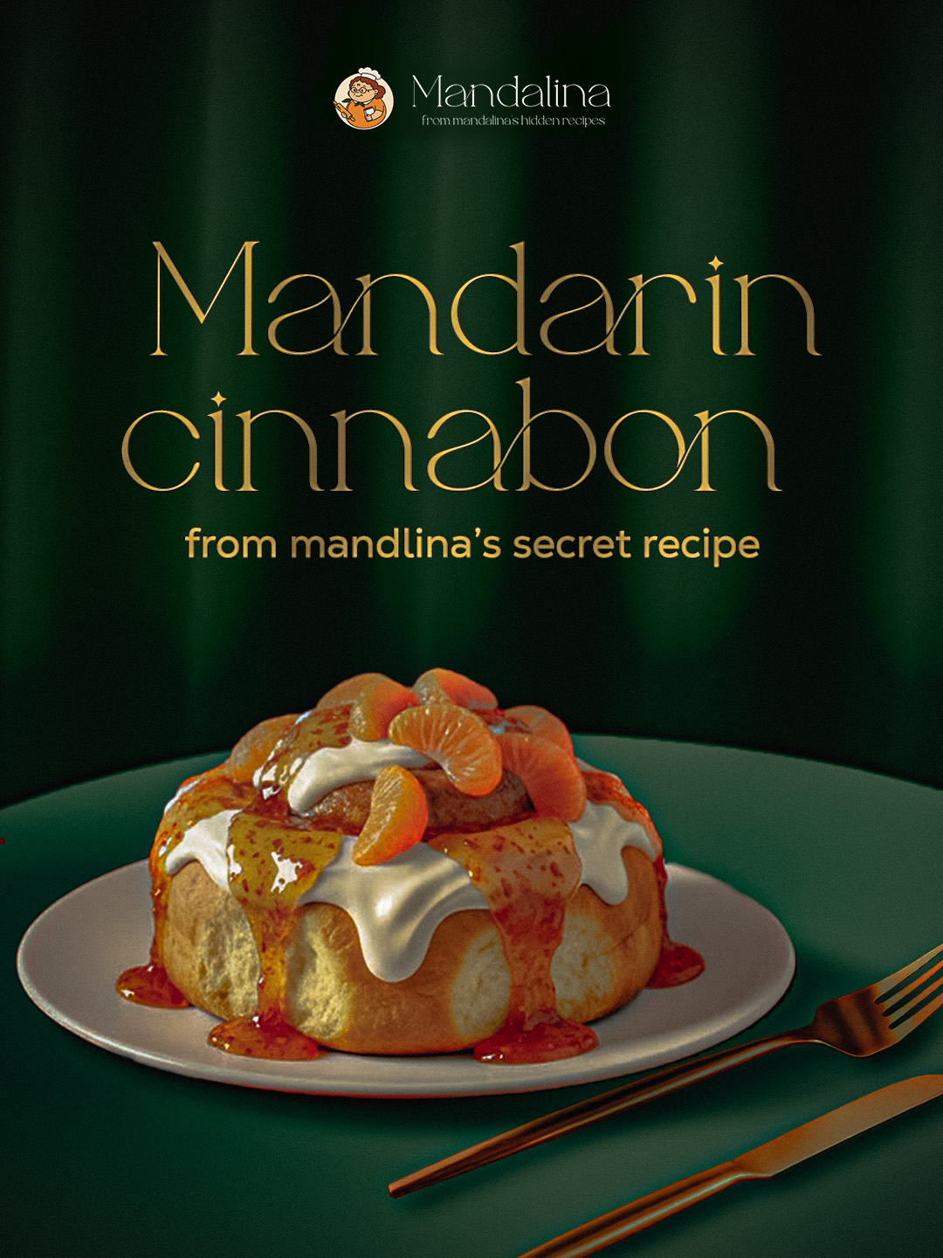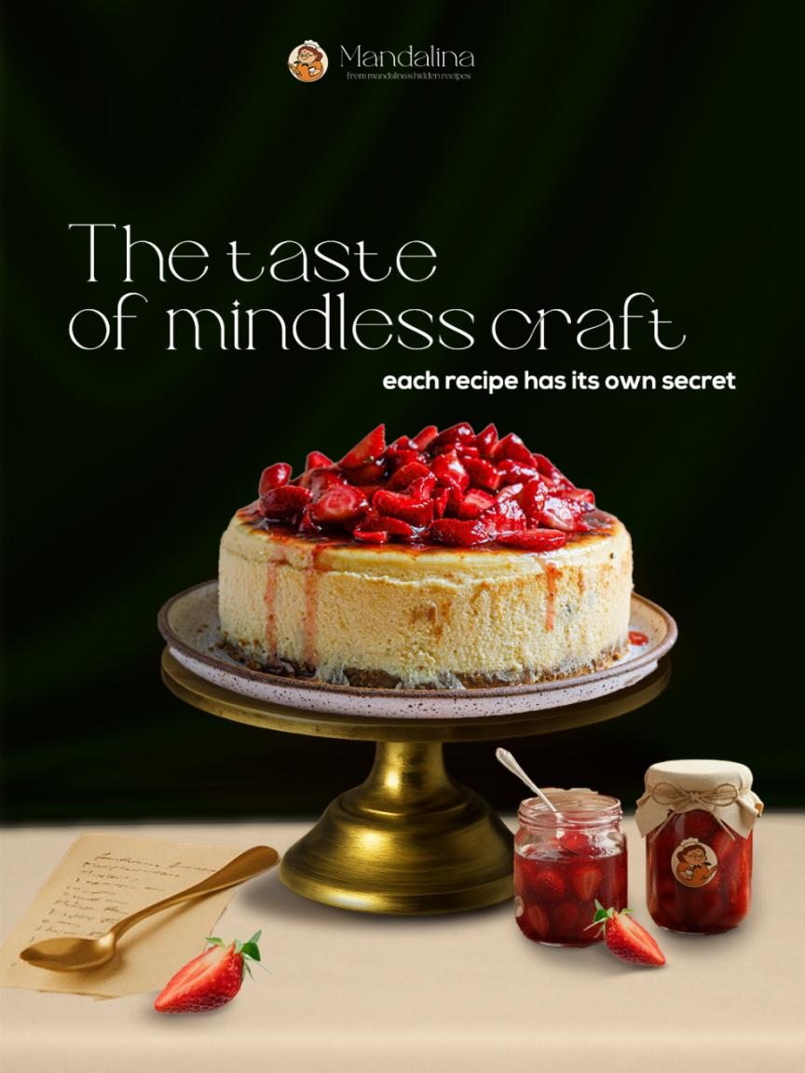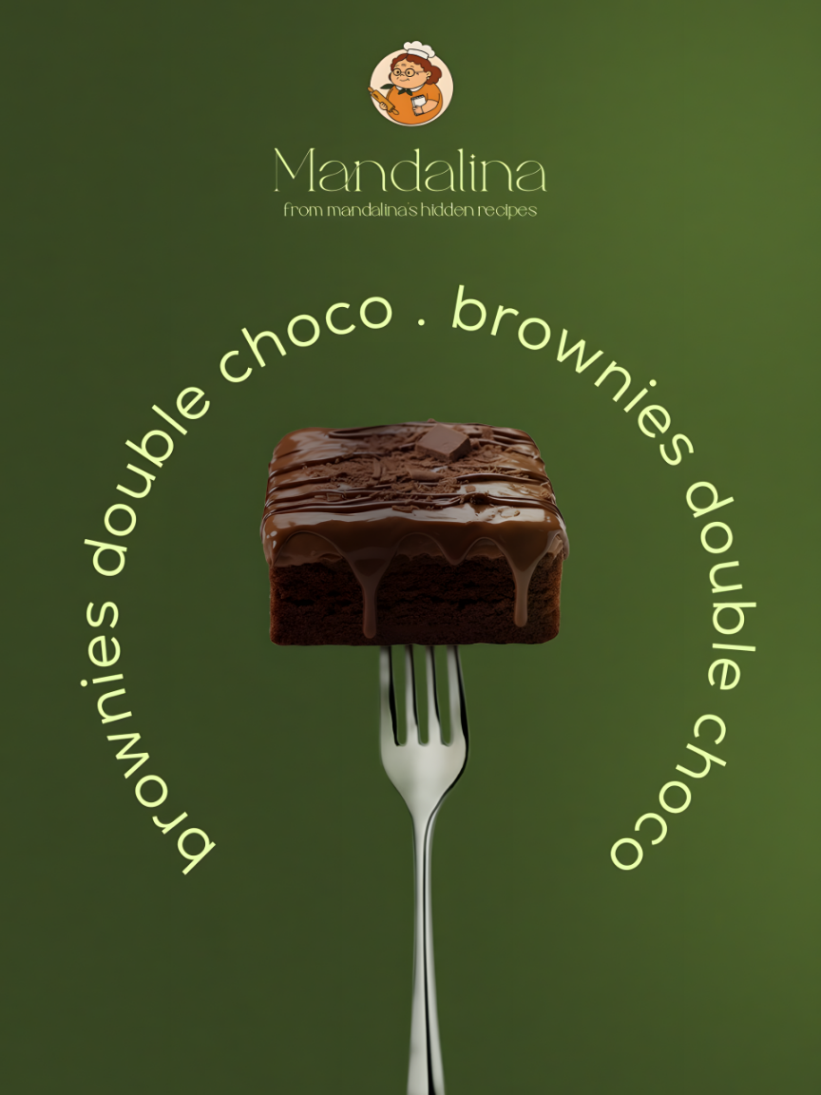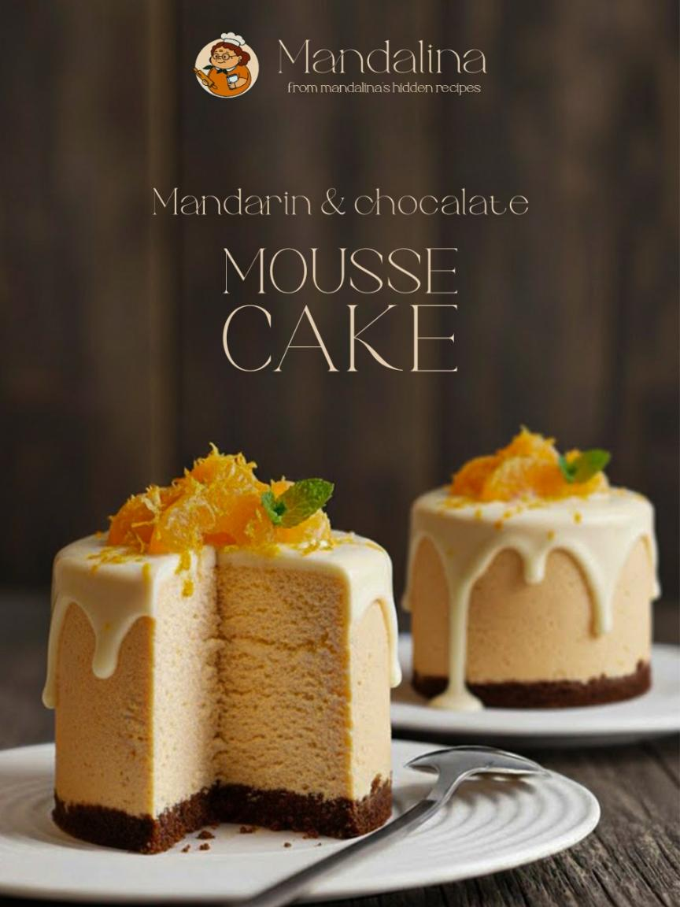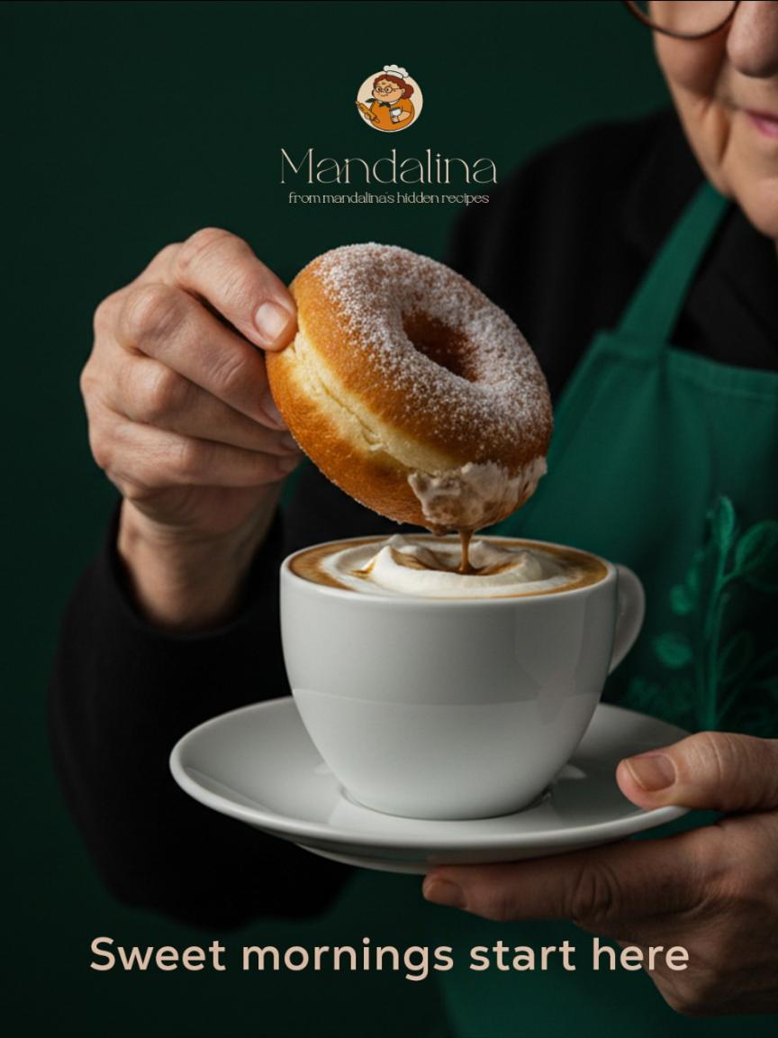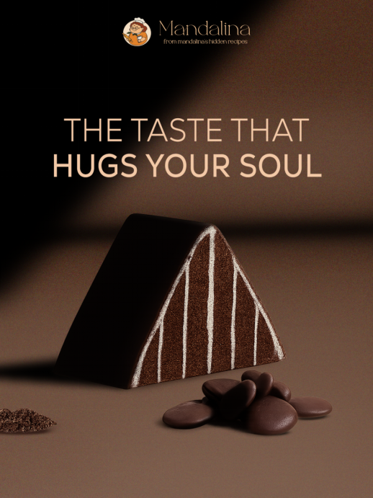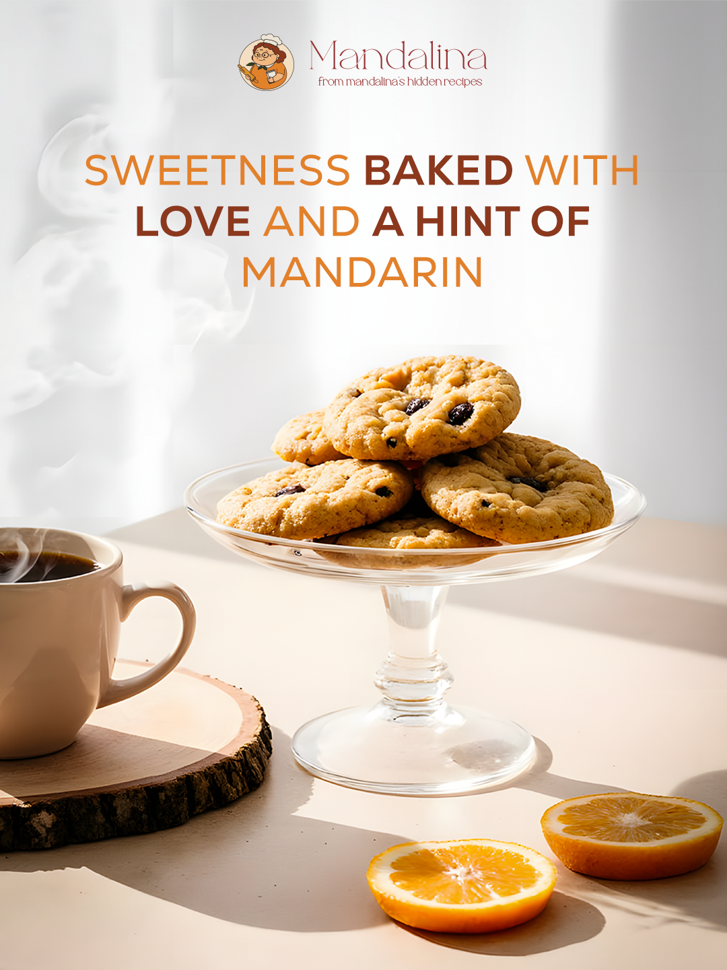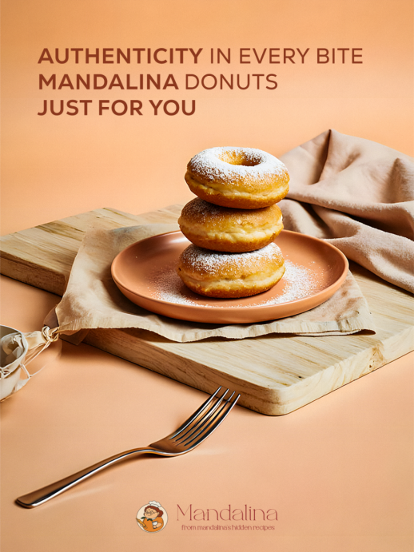**

## Poster

Minimal, elegant poster designs reflecting warmth and freshness.

## Complementary Products

Packaging by all members, social media by all members, and product identity applications.

## Review & Finalization

Ensuring all designs follow the brand identity system and visual rules.

## Final Presentation

A complete brand identity presentation with moodboard, colors, typography, logo concept, and applications prepared by Alzahraa Farag& Hager Ali and will be represented by all members.

# Roles & Responsibilities

• Alzahraa Farag: leader,packaging, logo sketches, social media & final presentation  
•Sawsan Khaled: logo designs,packaging & social media  
• Fayrouz Mahmoud: logo designs,packaging & social media  
• Hager Ali : logo sketches,packaging, social media & final presentation

# KPIs (Key Performance Indicators)

**Metrics to assess project success:**

**• Visual consistency score across all materials**

**• Audience engagement potential (evaluated through mockups & design testing)**

**• Brand clarity and character recognition**

**• Packaging usability & appeal**

**• Presentation quality and coherence**

**• Completion of project milestones within the expected timeline**

# Instructor Andrew Ibrahim

____________

# Project Files <https://github.com/zahraafarag2004/Mandalina-Brand-Identity>

# License